**ELPAC** 

**English Language Proficiency**

**Assessments for California**

# ELPAC and Alternate ELPAC SECURE DESTRUCTION AND RETURN INSTRUCTIONS

The English Language Proficiency Assessments for California (ELPAC) and Alternate ELPAC test materials used for the 2024–25 test administration will need to be either securely destroyed locally by the local educational agency (LEA) or returned to ETS for destruction on or before July 14, 2025.

## Summative ELPAC Test Materials List

* Unused kindergarten through grade two (K–2) Writing Answer Books (Forms 1–10)
* Voided K–2 Writing Answer Books (Forms 1–10)
* Unused student pre-identification labels
* Student rosters
* Printed *Directions for Administration* (*DFAs*)
* Paper–pencil test materials(Edition 1)
  + Used K–12 all-domain Answer Books
  + Used Test Books (grade three through grade twelve)
  + Used *Examiner’s Manuals*
  + Audio Script (Listening and Speaking)

## Initial ELPAC Test Materials List

* Used and unused Form 1 and Form 2 K–2 Writing Answer Books
* Unused pre-identification labels
* Student rosters
* Printed *DFAs*
* Paper–pencil test materials(Edition 1)
  + Used K–12 all-domain Answer Books
  + Used Test Books (grade three through grade twelve)
  + Used *Examiner’s Manuals*
  + Audio Script (Listening and Speaking)

## Initial Alternate and Summative Alternate ELPAC Test Materials List

* Student rosters
* Printed *DFAs*
* Picture cards (destroy for Summative Alternate ELPAC only)
* Test Item Preview booklets

## Destruction and Return Options

LEAs have the option to do one of the following:

1. Securely destroy the test materials locally
2. Provide confirmation of local destruction of all the ELPAC and Alternate ELPAC test materials by completing the 2024–25 ELPAC and Alternate ELPAC Materials Return or Destruction Certification form **no later than Monday, July 14, 2025**.

*or*

Return secure test materials for secure destruction via United Parcel Service (UPS)

1. Call UPS at 800-742-5877 to schedule a pickup.
2. **Do not use any courier other than UPS.**
3. Follow the directions for UPS shipping label creation. **Do not photocopy UPS labels.**

## LEA ELPAC Coordinator Instructions

## How to Create UPS Shipping Labels

* 1. Access the UPS account website. ***Note:*** UPS account information is included in the ELPAC and Alternate ELPAC Secure Destruction and Return Instructions that are emailed to LEA coordinators. The LEA’s assigned Success Agent can also provide account information.

1. Select the [**CONTINUE AS GUEST**] button.

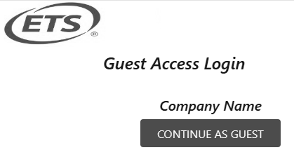

1. Once on the *Shipping Information* screen, enter the LEA’s county/district/school (CDS) code in the *Test Center Number* field and select the [**Search**] blue-arrow [[Search] right arrow icon.] icon to the right of the field. The LEA’s address information will populate in the other fields. Review the address information for the LEA. If the CDS code is not found or there are issues with the address, please contact the assigned LEA Success Agent for assistance. If needed, use the tool on the Success Agent Lookup web page at <https://www.caaspp-elpac.org/help/success-agent-lookup> to identify the LEA’s assigned Success Agent.

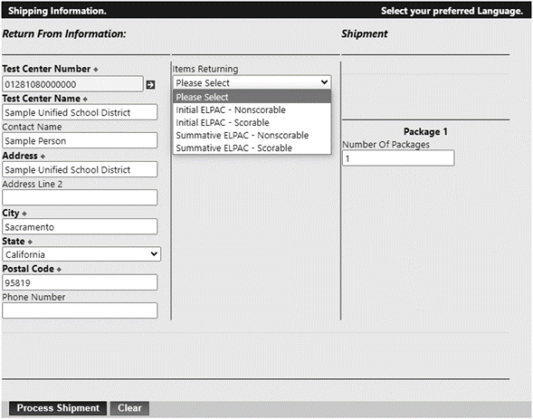

## LEA ELPAC Coordinator Instructions

## How to Create UPS Shipping Labels (continued)

1. Select the type of item that is being returned from the *Items Returning* drop-down list in the center column.
2. Select a *Nonscorable* option, which is presented in the image in step 3, for returning test materials to be destroyed.
3. If the LEA has multiple boxes, the total number of cartons can be entered in the *Number Of Packages* field. This will allow unique shipping labels to be printed for each box available. If only one box is being returned, please select *1* in this field to generate a single return label.

**Note:** For multiple carton returns, **do not** **copy one label for use on all of the boxes**. This will interfere with UPS’s ability to move the boxes within its network and will ultimately delay the shipments. **Unique shipping labels must be created for each carton.**

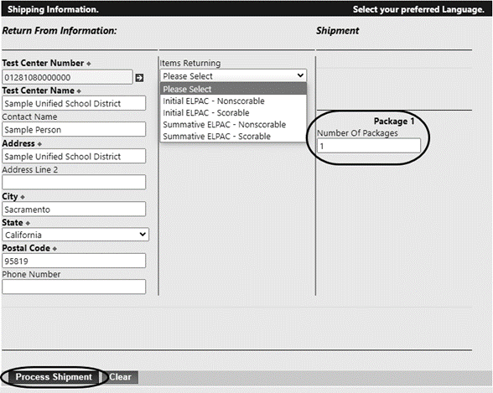

1. Select the [**Process Shipment**] button at the bottom-left corner of the screen.

## LEA ELPAC Coordinator Instructions

## How to Create UPS Shipping Labels (continued)

1. The UPS label will appear on the next screen. Choose the local printer and select the [**Print**] button.

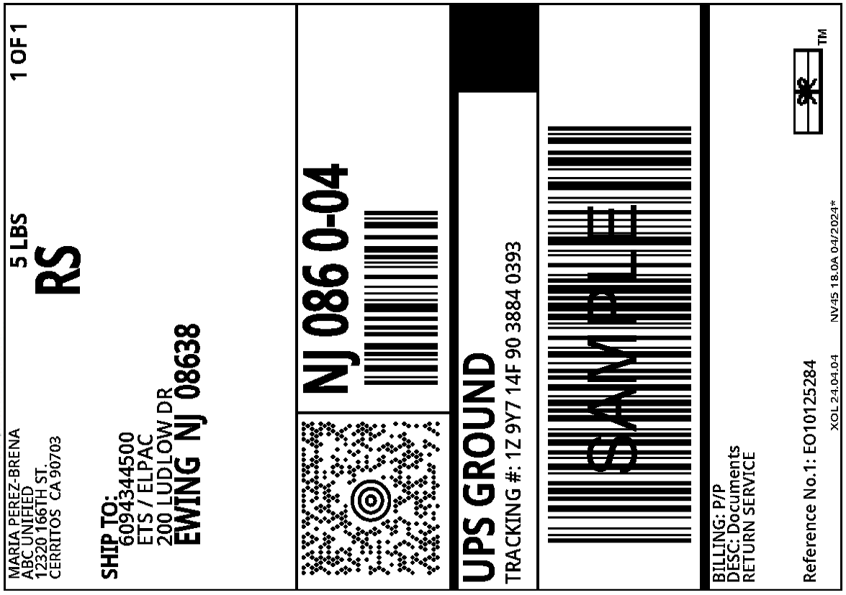

1. Complete the following steps on the top of the UPS label:
   1. Write on the label which box this is in the count (that is, “Box 1 of 3,” “Box 2 of 3”).
   2. Optional: Write in the LEA name and LEA code.
   3. Optional if more than one: Write in the school name and school code.
2. Affix the UPS label to the return carton.